

AUTOID Smartwatch-2.0M4-9.0
PRODUCT SPECIFICATION V1.0

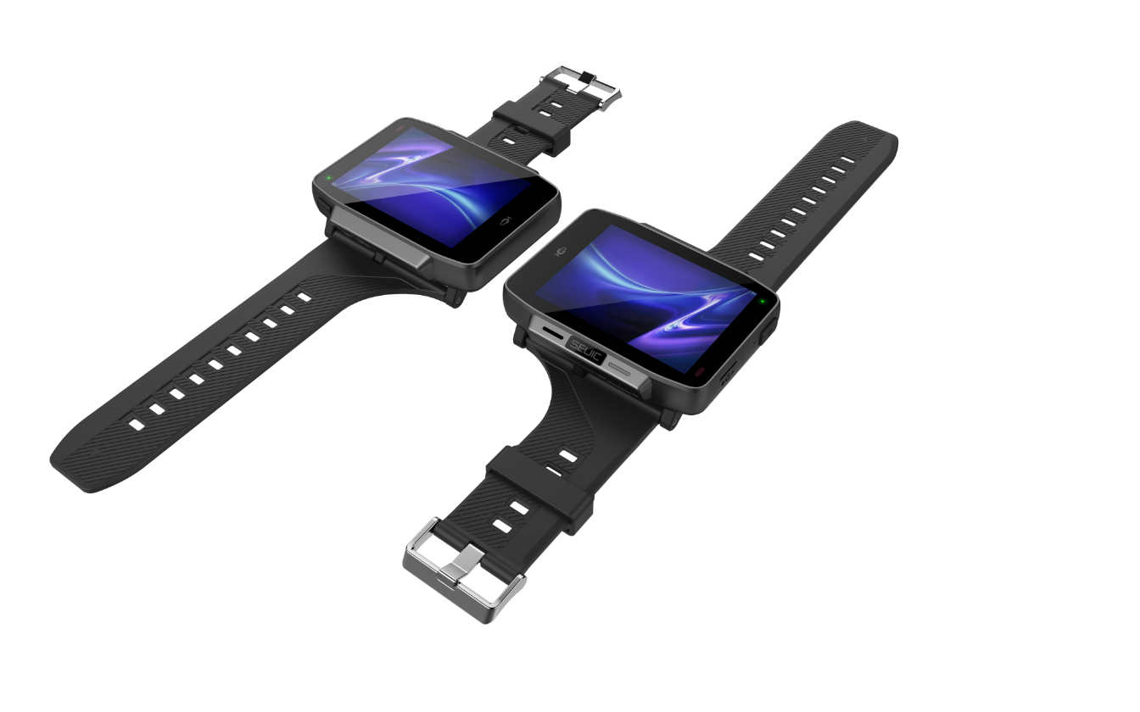

Manufacturer: JIANGSU SEUIC TECHNOLOGY CO., LTD

AUTOID Smartwatch-2.0M4-9.0 Performance, Physical and Environmental Parameters
CPU | MTK 4-core 2.0GHz
Operating system | Android 9.0
RAM | LPDDR3 3GB
ROM | 32GB
Interface | TYPE-C
Keys | 2 keys (power supply, custom), 1 million times life
Screen | 2.8 inch full view LCD, capacitive 3-point touch.
Screen | The resolution is 640 × 480 and the maximum brightness is 350nit
Power Supply | Non detachable 3300mah lithium ion rechargeable battery, 500 cycles, capacity more than 80%
Audio frequency | Built in speaker, 8 Ω, 1 W * 1. Built in dual microphone
Sensor | Acceleration sensor, proximity light sensor, electronic compass, gyroscope, barometer. Support to raise your hand to light up the screen.
Vibrating motor | support
Size | 54.7*80*17mm
Weight (including standard battery) | 100 g No strap
Working temperature | -20℃ to +60℃
Storage temperature | -30℃ to +70℃
Humidity | 5% to 95% RH No condensation state
Waterproof and dustproof industrial grade | IP67
Drop Level | 1.2m Marble Falls, 5 rounds on 6 sides, 30 times
Electrostatic discharge (ESD) | Air discharge of ± 15kV and direct discharge of ± 8Kv

